**Project Status Report – Progress #2**

**1. Overview 2**

**2. Key Milestones 2**

**3. Summary of Performance (Since Last Report) 3**

**4. Planned Work for Next Period 5**

4.1 Finalizing In-Progress Sections: 5

4.2 Enhancements & Optimization: 6

4.3 Quality Assurance & Testing: 6

**5. High-Priority Issues 6**

6. Issue Logs 7

**7. Conclusion 7**

## **1. Overview**

**Project Name:** TailTales

**Start Date:** Start Date: February 12, 2025

**Report Date:** March 12, 2025

**Team members:** Haroon Ahmed Bajwa, Aryan Tuwar, Vivian Zhonghui Liu, Mrinaal Nagpal

**TailTales** has moved forward into the second phase, focusing on refining core features, improving user experience, and ensuring system stability. Key developments include backend optimizations, UI enhancements, and additional functionality for seamless user interaction.

## **2. Key Milestones**

| **Milestone** | **Planned Date** | **Actual Date** | **Status** |
| --- | --- | --- | --- |
| Footer | February 12, 2025 | February 18, 2025 | ✅ Completed |
| HeroSection | February 12, 2025 | February 18, 2025 | ✅ Completed |
| Navbar | February 12, 2025 | February 18, 2025 | ✅ Completed |
| OurStory | February 12, 2025 | March 11, 2025 | ✅ Completed |
| ShopInfo | February 12, 2025 | March 11, 2025 | ✅ Completed |
| TrendingProucts | February 12, 2025 | February 18, 2025 | ✅ Completed |
| AppointmentSection | February 12, 2025 | - | ⏳ In Progress |
| BlogSection | February 12, 2025 | - | ⏳ In Progress |
| CartPage | February 12, 2025 | - | ⏳ In Progress |
| ProfilePage | February 12, 2025 | - | ⏳ In Progress |
| SignupSection | February 12, 2025 | - | ⏳ In Progress |

## **3. Summary of Performance (Since Last Report)**

* The website features a clean and intuitive navigation bar with key sections like **Shop**, **Book Appointment**, **Check Appointment**, **Our Story**, and **Contact**.
* Buttons (Cart, Profile) are clearly visible and well-positioned for easy access.



* The **Shop** section is structured neatly, with clear product images, names, and prices.

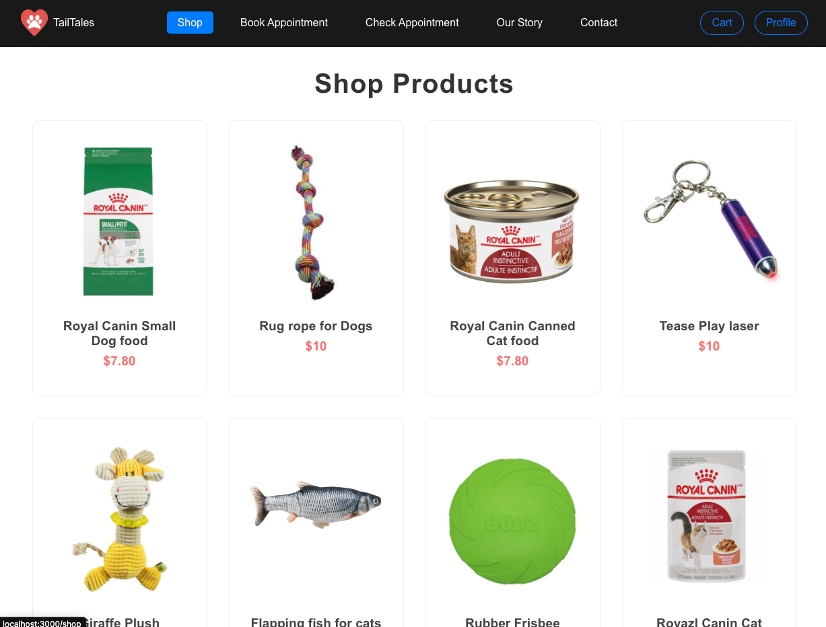

* The **Trending Products** section offers dynamic visibility for popular products, encouraging user engagement.
* The Trending Products section features a horizontal slider, making it engaging for users to browse highlighted items.

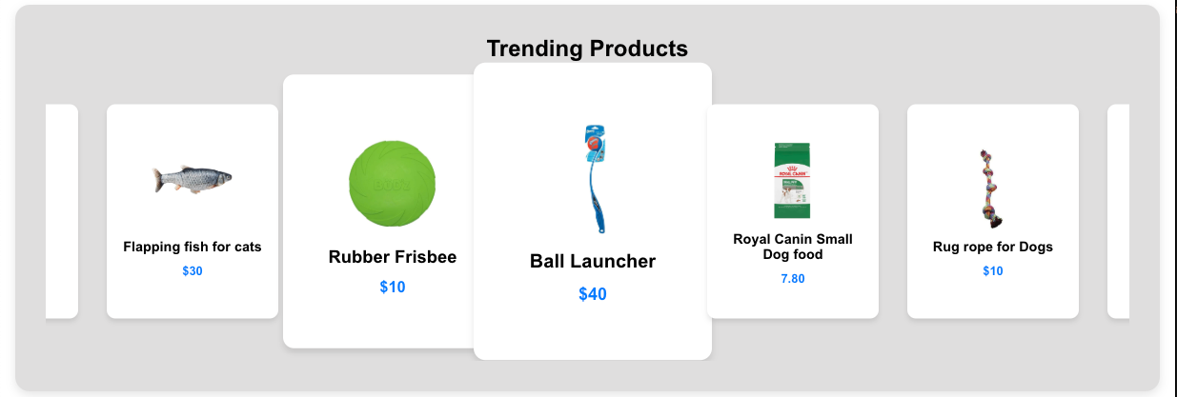

* The **Our Story** page uses an appealing layout, with a well-structured introduction, vision, and key reasons why users should choose TailTales.

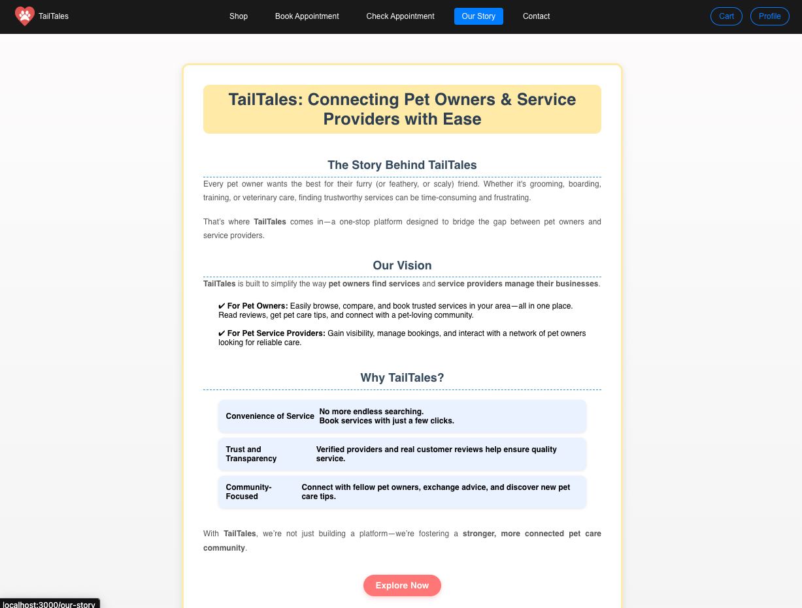

* In Jira, while progress is steady, upcoming priorities include completing remaining implementations and transitioning pending tasks into development. Overall, the project is advancing but requires further execution to stay on track for upcoming deadlines.

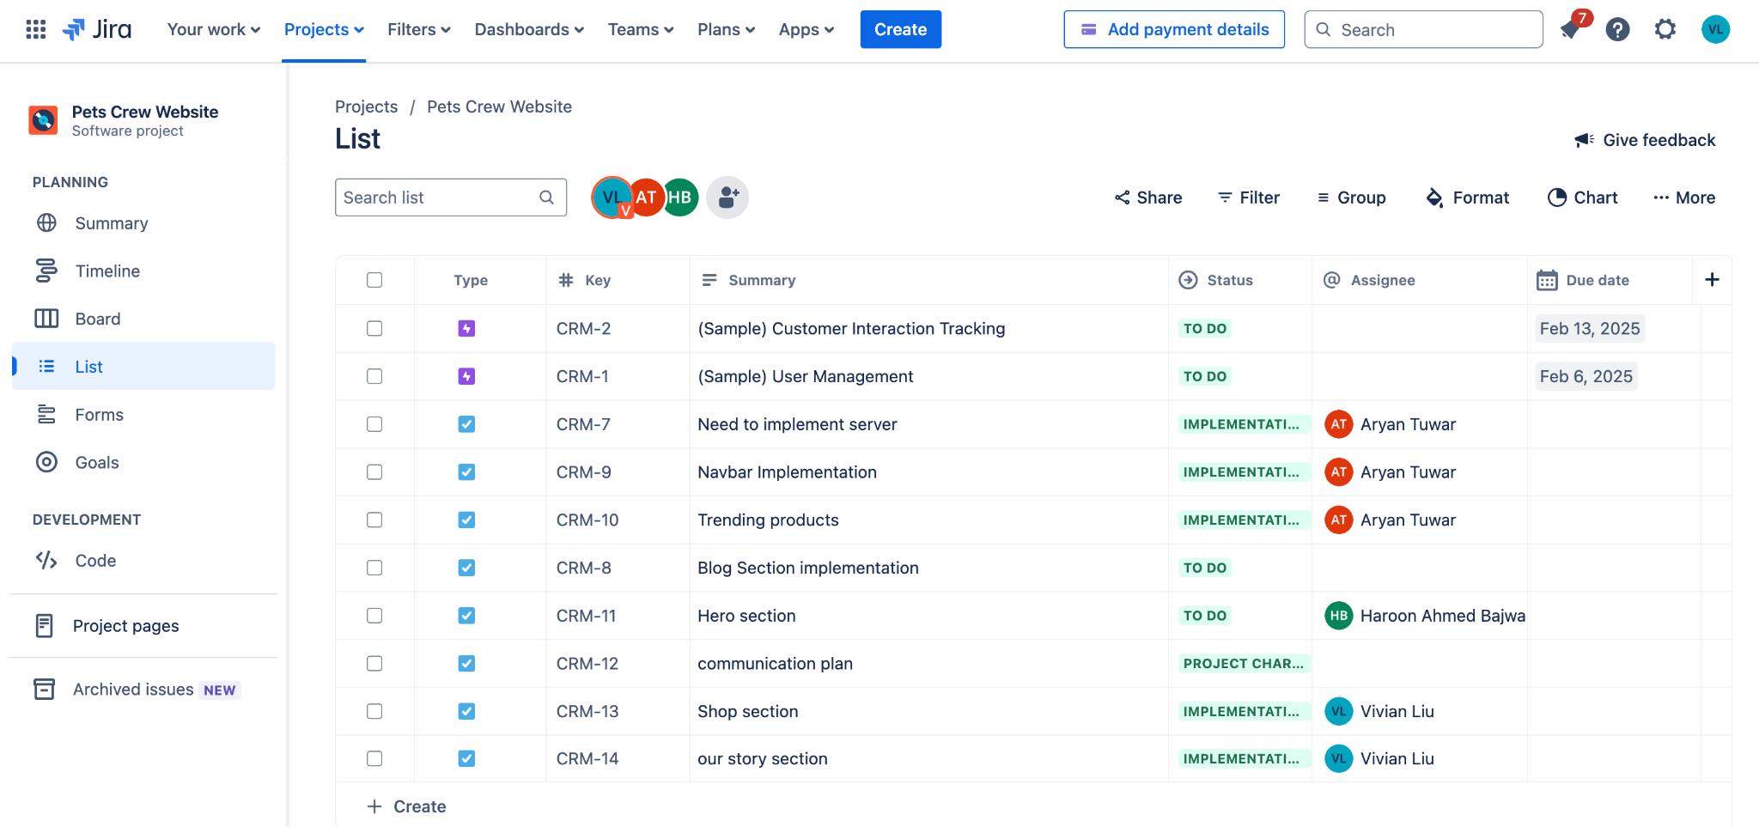

## **4. Planned Work for Next Period**

For the next reporting period, our focus will be on completing in-progress features and addressing any outstanding development tasks. Key priorities include:

### **4.1 Finalizing In-Progress Sections:**

* AppointmentSection
* BlogSection
* CartPage
* ProfilePage
* SignupSection

### **4.2 Enhancements & Optimization:**

* Refining UI elements for a more seamless user experience.
* Addressing performance issues related to loading times and responsiveness.
* Improving backend efficiency to reduce request handling time.

### **4.3 Quality Assurance & Testing:**

* Conducting internal testing for all completed features.
* Gathering user feedback for iterative improvements.
* Resolving any major bugs before the next development phase.

## **5. High-Priority Issues**

The following issues require immediate attention to ensure timely project completion:

* **Delayed Sections:** Some sections, such as **AppointmentSection**, **BlogSection**, and **ProfilePage**, remain incomplete. These need to be expedited to meet the project timeline.
* **Performance Optimization:** Backend optimizations are necessary to reduce server response times and improve user experience.
* **Bug Fixes & Testing:** A few unresolved UI/UX bugs require debugging and patching before launch.
* **Jira Task Management:** Tasks need to be better tracked and transitioned to ensure smooth development flow.

## **6. Issue Logs**

This section provides a record of key challenges encountered and their resolutions:

| **Issue** | **Description** | **Status** | **Assigned To** |
| --- | --- | --- | --- |
| Navbar responsiveness | Navbar layout breaks on smaller screens | Resolved | Aryan Tuwar |
| Cart functionality | Users unable to update quantity in cart | In Progress | Aryan Tuwar |
| Slow API response | Backend APIs taking longer than expected | Pending | Haroon Ahmed Bajwa |
| Profile page loading | Page fails to load on certain browsers | Testing | Mrinaal Nagpal |

## **7. Conclusion**

The project is making steady progress, with several milestones successfully completed. While a few sections remain under development, the team is actively working on resolving high-priority issues. The focus for the next period will be on completing in-progress sections, optimizing performance, and ensuring a smooth user experience.

By addressing the outlined challenges and sticking to our development plan, we aim to stay on track for the final project deadline.